Question 1
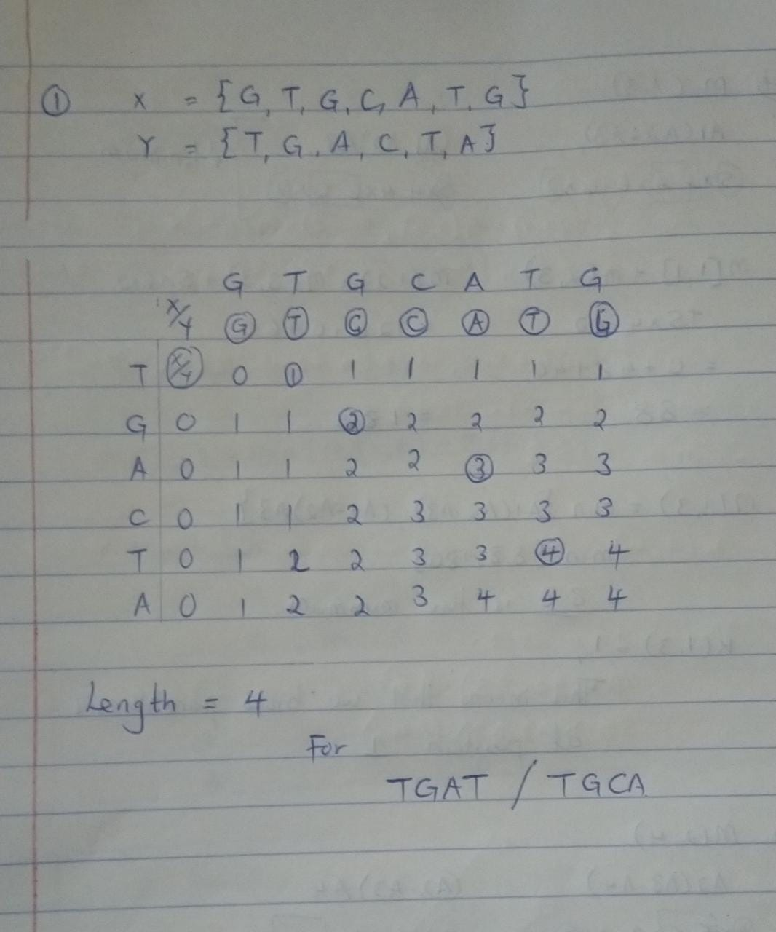

Question 2:

#include <bits/stdc++.h>
using namespace std;
void bino_coeff(int k,int n)
{
int C[n + 1][k + 1];
int i, j;

// Caculate value of Binomial Coefficient
for (i = 0; i <= n; i++) {
for (j = 0; j <= min(i, k); j++) {

if (j == 0 || j == i)
C[i][j] = 1;
else
C[i][j] = C[i - 1][j - 1] + C[i - 1][j];
}
}
for(int i=0;i<=n;i++)
{
for(int j=0;j<=min(i,k);j++)
{
cout<<"C("<<i<<","<<j<<") ="<<C[i][j]<<endl;
}
}

}

int main() {
int k,n;
cin>>n>>k;
bino_coeff(k,n);
return 0;
}

Question 3:
#include<iostream>
#include<cstring>
#include<cstdlib>
#include<string>

//user-defined header file
#include "LCS.h"
using namespace std;

// main function
int main()
{
// declare arrays as characters
char X[100];
char Y[100];

// user input
cout << "Enter first string: ";
cin >> X;
cout << "Enter second string: ";
cin >> Y;

// size of the strings
int m = strlen(X);
int n = strlen(Y);

// Matrix initialisatiion
int **C;
C = new int*[m+1];

int I, J;
for(I=0; I<=m; I++){
C[I] = new int[n+1];
}

LCS(C, X, Y, m, n);

return 0;
}

// method to find and print the LCS of passing strings
void LCS(int **C, char X[], char Y[], int m, int n )
{
// Matrix computation
for (int i=0; i<=m; i++)
{
for (int j=0; j<=n; j++)
{
if (i == 0 || j == 0) {
C[i][j] = 0;
}
else if (X[i-1] == Y[j-1]) {
C[i][j] = C[i-1][j-1] + 1;
}
else
{
C[i][j] = max(C[i-1][j], C[i][j-1]);
}
}
}

// index of lcs in Matrix C
int index = C[m][n];

// array to store lcs strings
char longestCommonSubsequence[index+1];

// Set the terminating character
longestCommonSubsequence[index] = '\0';

// begin with the right-most-bottom-most corner and
// store characters in longestCommonSubsequence[] one by one
int i = m, j = n;
while (i > 0 && j > 0)
{
// If current character in X[] and Y[] is same, then it is a part of LCS
if (X[i-1] == Y[j-1])
{
// Put it in result
longestCommonSubsequence[index-1] = X[i-1];

// decrease values of i, j and index by 1
i--;
j--;
index--;
}

// If it is not same, then calculate the larger of two
// and move to the direction of larger value
else if (C[i-1][j] > C[i][j-1]){
i--;
}
else{
j--;
}
}

// print LCS
cout << "\nLongest Common Subsequence of " << X << " and " << Y << " is: " << longestCommonSubsequence;
}
LCS.h

#ifndef HEADER_FILE
#define HEADER_FILE

// initialize method to find and print LCS of both strings
void LCS(int **C, char X[], char Y[], int m, int n );

#endif

Program Output
Enter first string: CGATAATTGAGA
Enter second string: GTTCCTAATA

Longest Common Subsequence of CGATAATTGAGA and GTTCCTAATA is: GTTTAA

Question 4:
